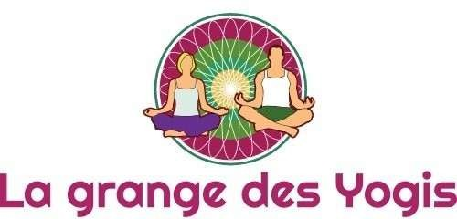

Yoga Douceur, Hatha Yoga, Méditation, Yin Yoga
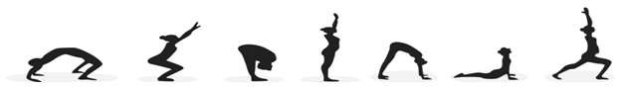

COURS COLLECTIFS
Lundi 10h-11h30 Yoga Douceur  18h15-19h45 Hatha Yoga 12h30-13h30 Hatha Yoga 20h15-21h30 Yin Yoga 
Mardi 9h-10h30 Hatha Yoga 18h15-19h15 Meditation 
19h40-21h10 Hatha Yoga 
Mercredi 17h45-19h Yoga KumNye

19h15-20h45 Hatha Yoga 19h15-20h30 Hatha Yoga
Jeudi | 9h -10h30 | Hatha Yoga
Vendredi | 9h-10h15 | Yin Yoga

ATELIERS VENDREDI SOIR ET WEEK-END


(infos Facebook et site web)

Marie-Agnès Tabet | 06.11.95.12.28
Agnès Lorenzelli | 07.80.37.34.23
Nathalie Panayoti | 06.18.97.85.80


Pages Facebook et Instagram : lagrangedesyogis
13 chemin de la combe, Chuzelles  lagrangedesyogis@gmail.com http://lagrangedesyogis.fr

